LTB Sales Portal - System Development Progress
Fourth Milestone
----------------------------------------------------------------------------------------------------------------------------------------
Currently, 85% of the goals set for this milestone have been achieved. Even though most of the data issues have been solved, the delay caused by gathering and analyzing new data sources contributed to the 15% lag experienced in Milestone III. Also, the lag in the interface development contributed to a delay in some of the controllers of this project. This is because functions of objects such as ProFormas, Programs, and Collections are directly associated to events that are caused by actions performed by a user. Therefore, the development and implementation of these controllers should be done during the same stage. Note: the lag in the interface development is due to reasonable factors that can be disclosed by True Interaction, per request, at any time. Overall, all models, controllers and GUI (Graphical User Interface) for objects of high priority have been developed and implemented. Objects that are missing its GUI and implementation, such as log, will be developed and implemented during the evaluation stage of this.

Milestone Goals:

The data analysis task:

- The only task is the System Evaluation:
  - User-Based Model:
    - Driver
    - Customer

  - Strategy-Plan Mode:
    - Agreement
    - ProForma
    - Demand Solution
    - Item

Project Progress:
A brief summary of the work done to achieve the goals mentioned above is being described below, to obtain a more descriptive information above the current state of the project you can access the files provided in the reference section of this report.

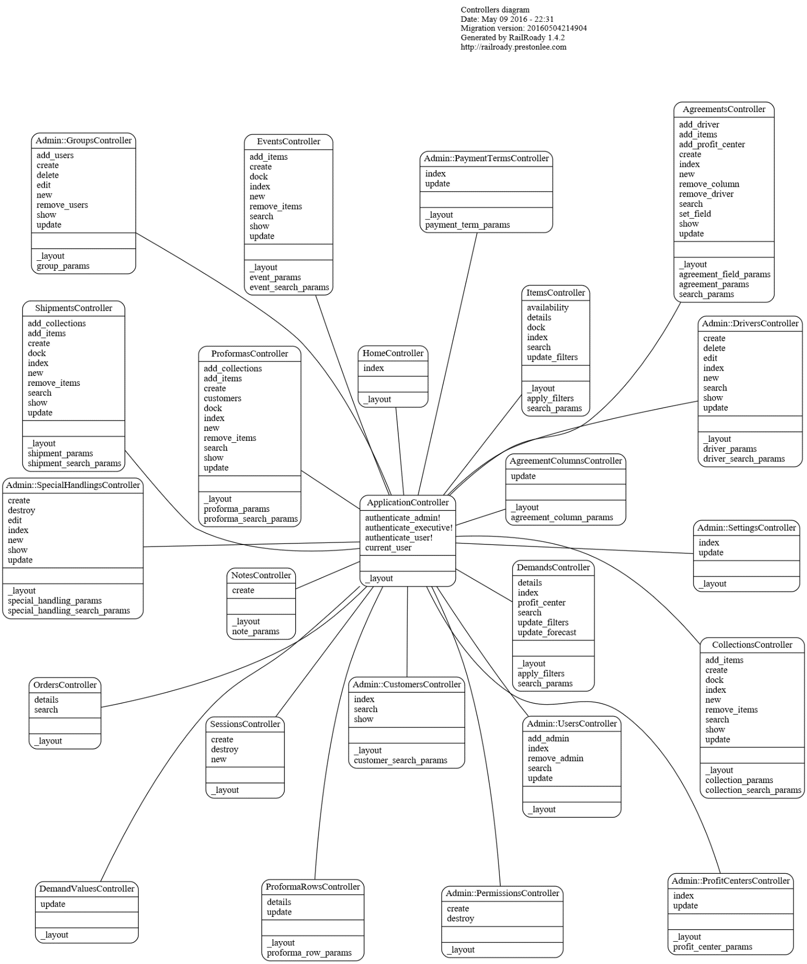

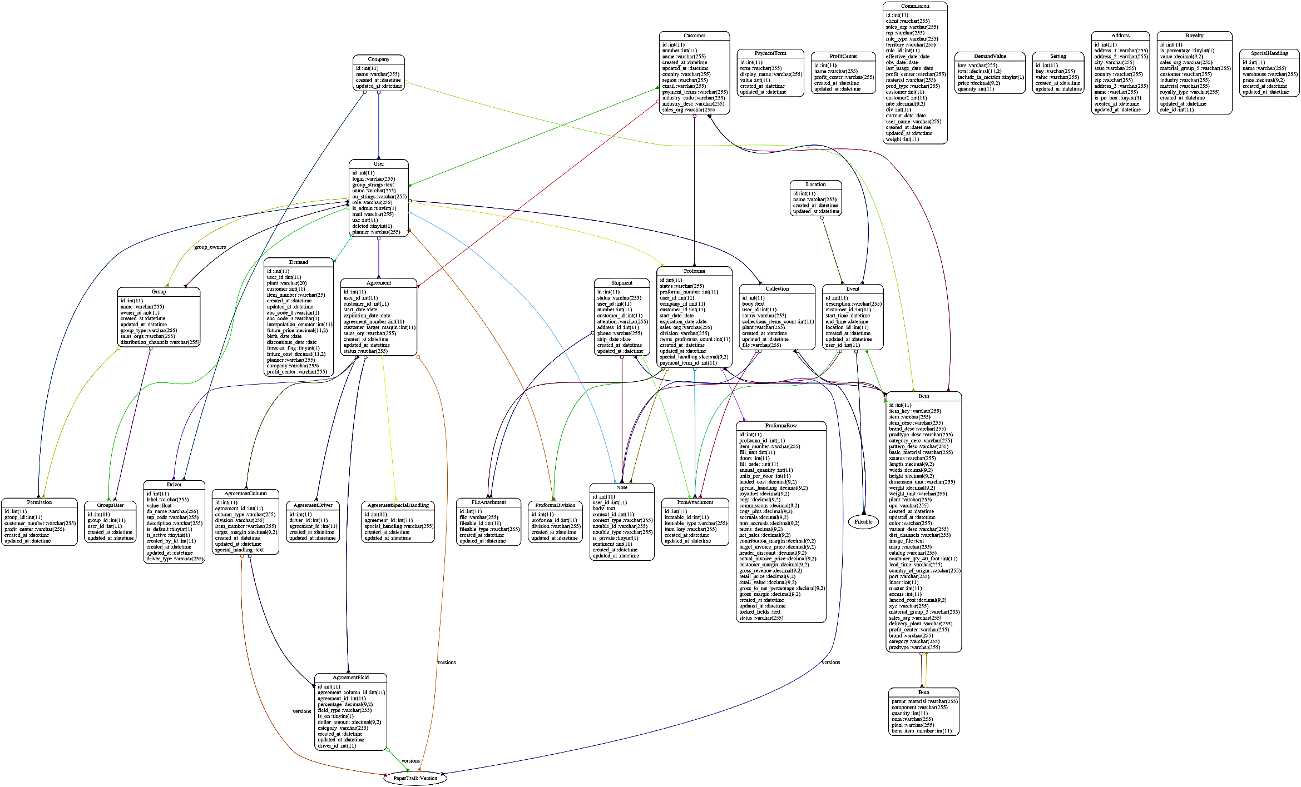
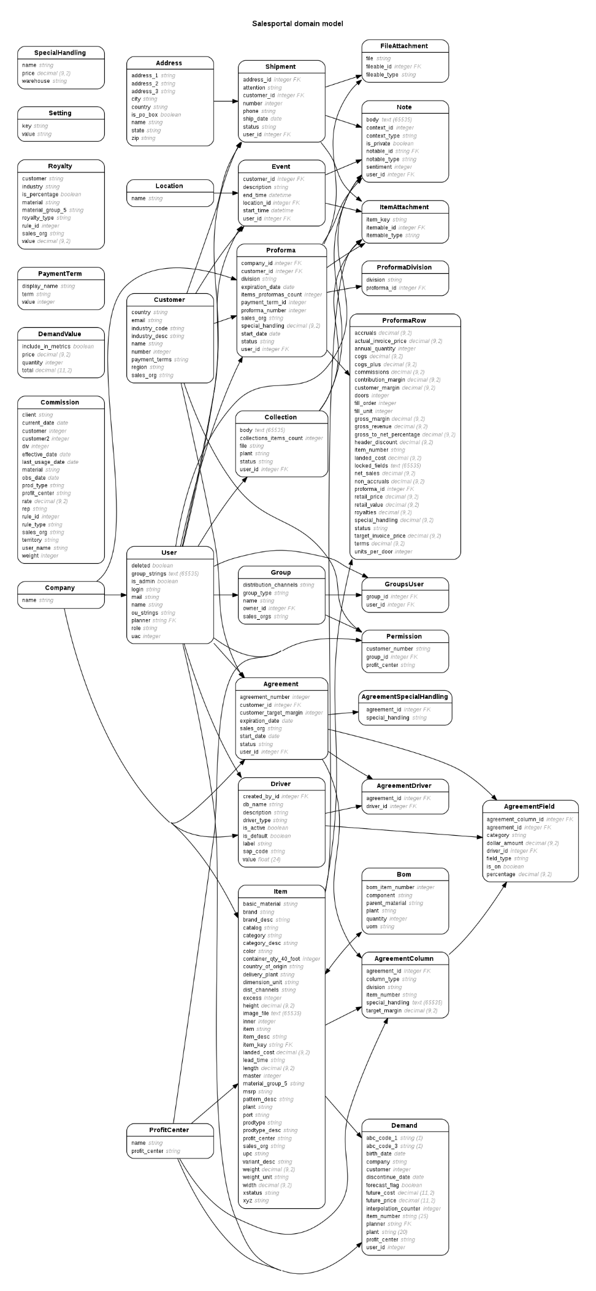
As illustrated above the implementation of the user-based and the strategy-plan system models have been successfully done. The strategy-plan system contains the “Operation Methods” - these are all methods utilized by sales group, which are also accessible by the finance group. This integration is the overall result of the “Life Time Brand(LTB) Sales Portal” system model implementation, which is being illustrated below.

Note: the current diagram of the system model development is subject to changes, especially now that the system is in its evaluation stage -which is the last stage of this project. Changes to the current system implementation can be monitored by accessing the ERD report.

Next Step:
The next step is the System Evaluation stage of the application features that have been developed and implemented to meet the client’s needs. This step will consist of 1) individually evaluating all methods and identify possible issues, 2) debug identified issues and improve system, 3) deploy a system prototype and allow customer to test all application features.

Reference Files:

-----------------------------------------------------------------------------------------------------------------------------------------
System and Data Structure Design Week 0
------------------------------------------------------------------------------------------------------------------------------- Sources
- Understanding the Company’s Goal LTB-Sales-Portal-Requested-Features
- Understanding the Data Understanding-Data-Directory
- Design System Architecture Data-Schema/PDFs/Model-Integration-System
- Design Data Structure Wires/Frames-for-User-Interface

-----------------------------------------------------------------------------------------------------------------------------------------
Data Analysis
-------------------------------------------------------------------------------------------------------------------------------Week 4
- Data Preparation Data-Handling-Google-Spread-Sheet
- Data Exploration Notes/Exploring-the-Data
- Modeling and Evaluation Notes/Exploring-the-Data/Training-and-Testing

----------------------------------------------------------------------------------------------------------------------------------------
System Development
-------------------------------------------------------------------------------------------------------------------------------Week 8
- Develop Permissions Based System Model MVC Application
- Users & Groups Methods
- Develop Strategic Plan System Model schema
- Finance Group Methods
- Operations Methods
- Resulted System Model ERD report

------------------------------------------------------------------------------------------------------------------------------------------
System Implementation
--------------------------------------------------------------------------------------------------------------------------------Week12
- Implement User Based System Model Web Application
  - Groups, Users & Permissions Assignment
- Implement Strategy Plan System Model Web Application
  - Programs
  - Pro Formas, Collections and Performance
  - Graphics User Interface

